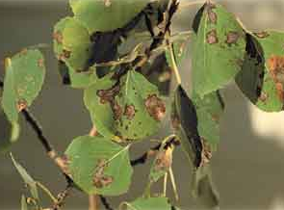
Aspen Leaf Blight

What is Aspen Leaf Blight?
Aspen Leaf Blight (or Marssonina Leaf Spot) is a foliage disease that affects both aspen and poplar trees in our region. The fungus overwinters in infected shoots and is spread in the early spring (End of April – Mid May) when warm, wet conditions occur. The fungus produces microscopic spores that are spread by the wind to young developing leaves. When the disease is active, small black spots appear. These spots can eventually grow together causing large dead patches.

Can Aspen Leaf Blight be Controlled?
Yes! However, timing of disease control applications (fungicides), fertilization, as well as cultural practices are crucial in maintaining plant health.

Recommendations:
- Fertilize: Fertilization will help strengthen the overall health of the plant. This can be done in the late fall (November) or early spring (March).

- Fungicide Treatments: The 1st treatment is scheduled when the leaves are at ¼ leaf stage. The second follow-up treatment is 3-4 weeks later.
NOTE: Fungicides are generally short lived (3-4 weeks). This is why a minimum of 2 applications are recommended during leaf development (¼ - full leaf stage). This is when leaf spot is most active.

